**NIRMAL PATEL’S SPECIFIC ROLE ON WELLS FARGO – (PROJECT NAME)**

Nirmal Patel’s main role is to build and support LUCAS (Loan Underwriting Collateral Analysis) application that is used by the capital finance group to store, maintain, track and administer asset-based loans. Asset-based loans are a commercial loan whose collateral is usually the client's inventory and/or accounts receivable. Borrowing decisions are made based on the most current customer collateral Information.

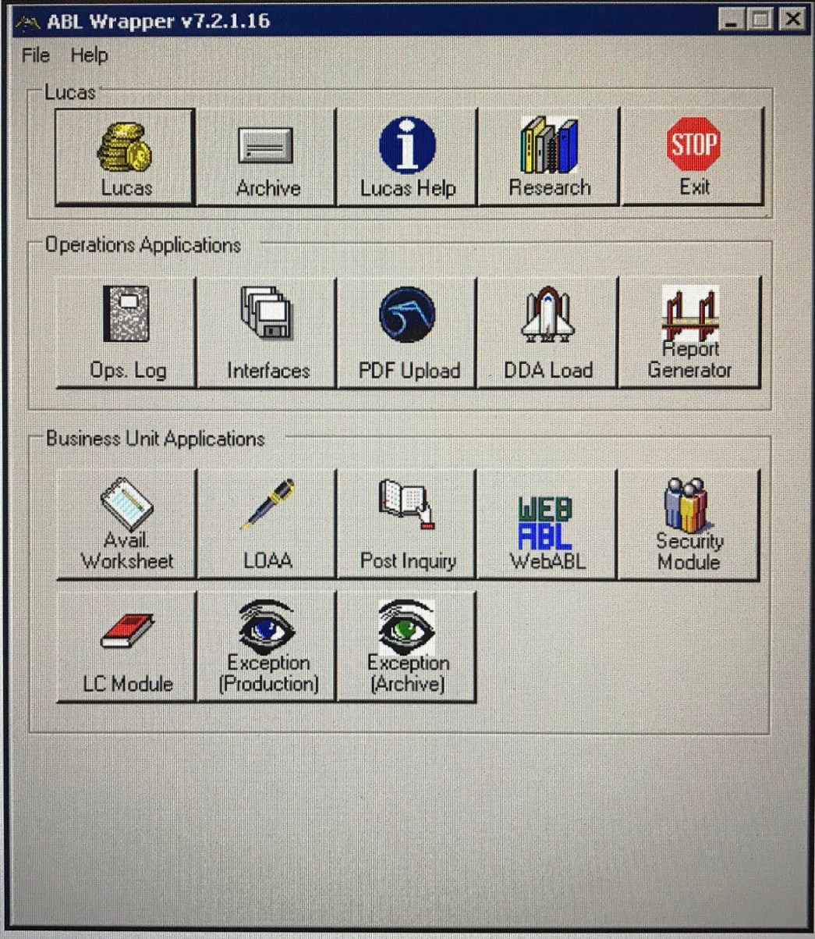

Nirmal builds and supports the LUCAS application various modules with his academic and prior work experience by using different Microsoft tools – VB.Net, C#, ASP.Net, SQL Server, SSRS, SSIS, Webservices , Visual Studio Framework 2017.

LUCAS application development includes enhancing the application with the latest business requirements and supporting the system to meet the New Banking regulations.

Nirmal changed the mode of authentication of WEB API from credential based to Venifi certificate. His day to day work includes automation of manual work and code optimization for a better performance.

Nirmal worked closely with stakeholders and Business analyst and developed a flow for tax withholding. He developed new intranet application using HTML 5, CSS3 and Angular.

Nirmal is specialized in performing the code scans using HP Fortify tool and fixing the bugs before hitting the production. He has implemented various Deployment tools like Jenkins, Urban Code deploy for continues integration and continuous deployment of all the LUCAS modules.